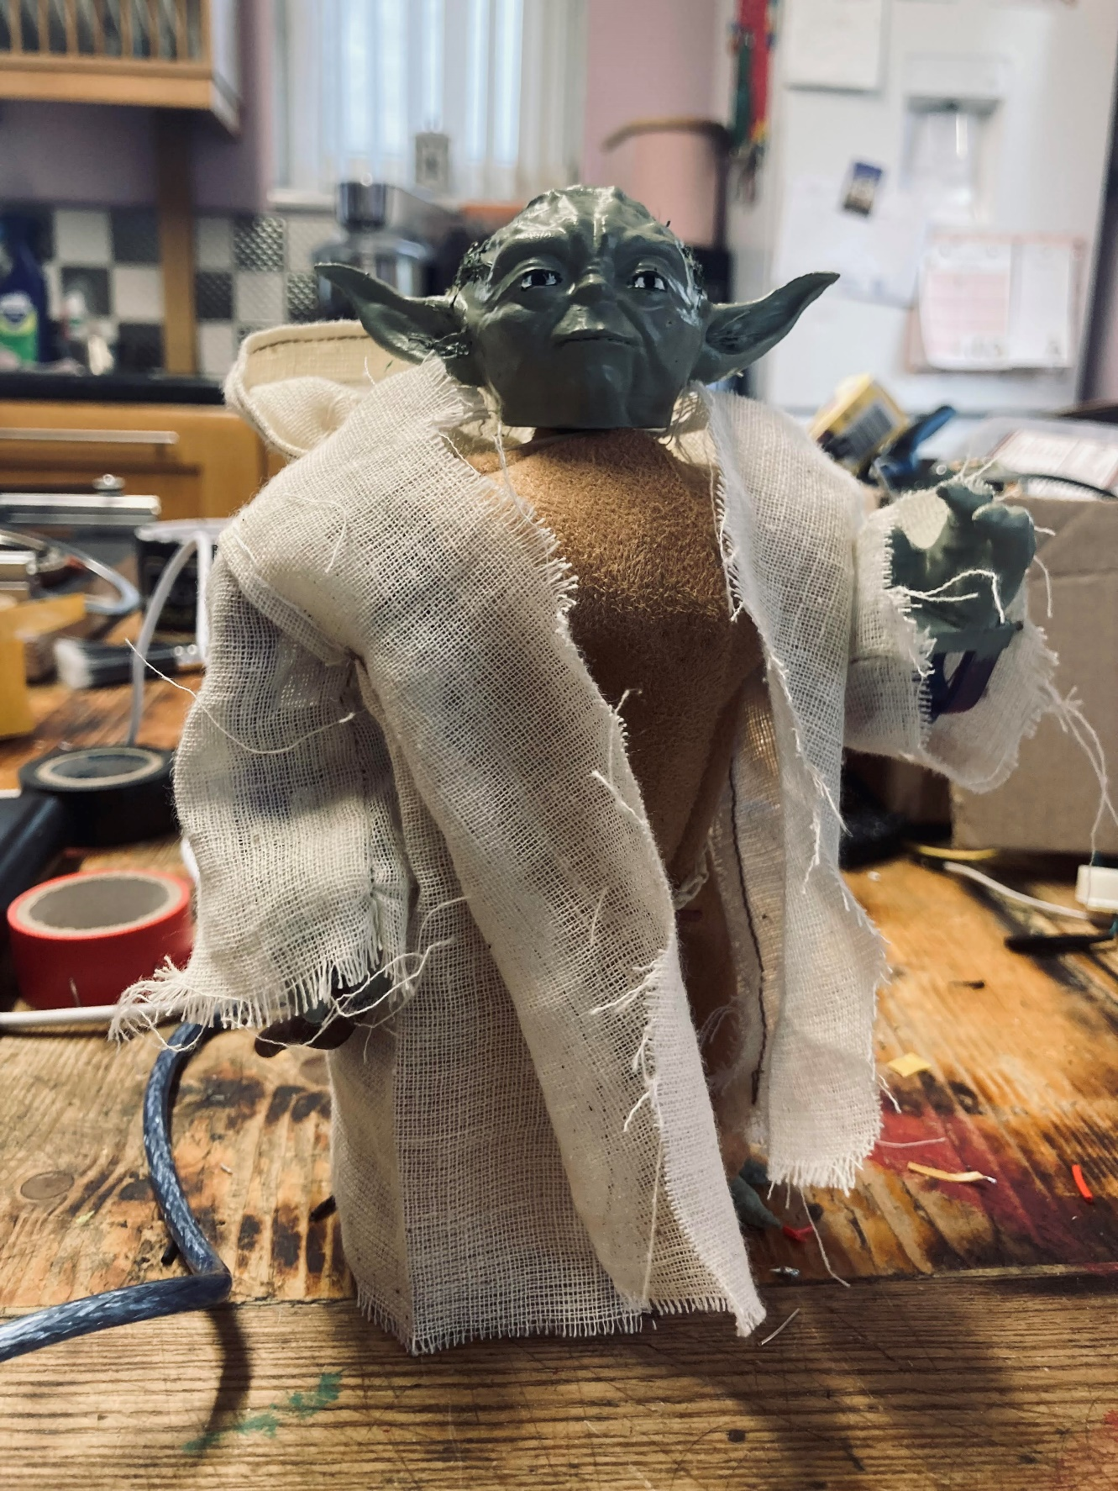Yoda Assembly Instructions:

# Parts List:

X1 Arduino Uno.

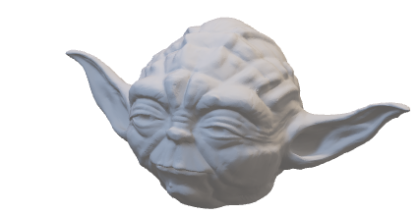X1 Yoda head.

X1 Yoda lower torso section.

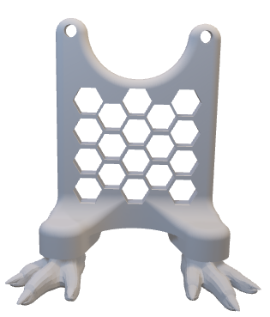

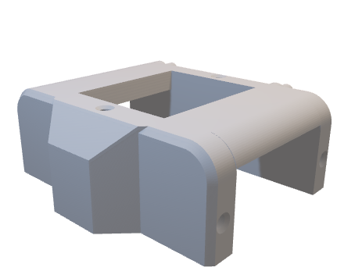X1 Yoda upper torso section.

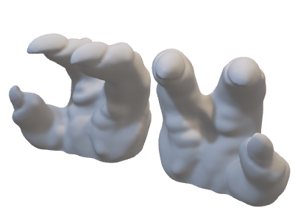X2 Yoda Hands.

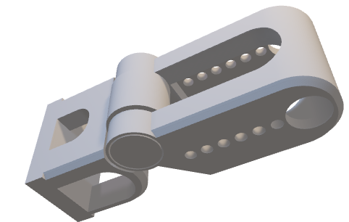X2 Yoda hinged arms.

X2 m3 nuts

X2 single prong servo horn (and screws)

X3 m3*10mm bolts

X3 micro servos (optional metal gear).

X6 m3*6mm bolts

# Assembly:

Step 1: attaching Arduino to lower torso.

Using the “Yoda lower torso section” and the Arduino uno, use 2 m3*10mm bolts and 2 m3 nuts to attach the Arduino (with pins facing backwards, and usb bort facing down towards the ground) do not use the seemingly purposefully made holes as I have no clue what “whacky backy” I must have consumed to think that would have been the right placement for the bolts, instead use the ones which look like they were made with a prisoners tooth brush shiv.

Tighten till finger tight, and not crushing the plastic portion.

Step 2: attaching servo motors to the upper torso.

Place the servo motor with the side with the gear closest to the back away from you, we will refer to this as the back side of the servo.

***Back of servo.***

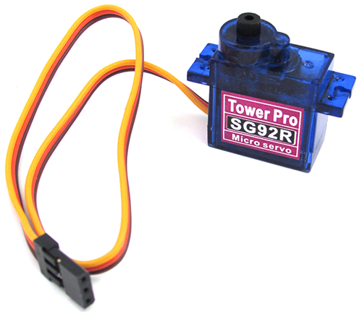

Place one of the servos into the top slot of the Yoda upper torso section so that the screw mounts are on top of the torso piece.

Affix using two m3*6 bolts through the screw mounts and into the torso section.

To mount the arm servos, place them in the sides of the Yoda upper torso section with the back of the servos facing the back of the torso piece, (the side with the protruding peg(s)).

Thread the servo wire up through the gap next to the main head servo which should be previously installed.

Affix the servo using the back screw hole, with a m3*6mm bolt, do not screw in all the way, just enough to loosely hold the servo in the torso section.

Thread the servo wire back down the hole next to the main head servo, the wire should lay flat over the top of the arm servo, then feed the wire through the front of the torso where there is a protruding section, meant for the wires to feed through.

The end assembly should look like this:

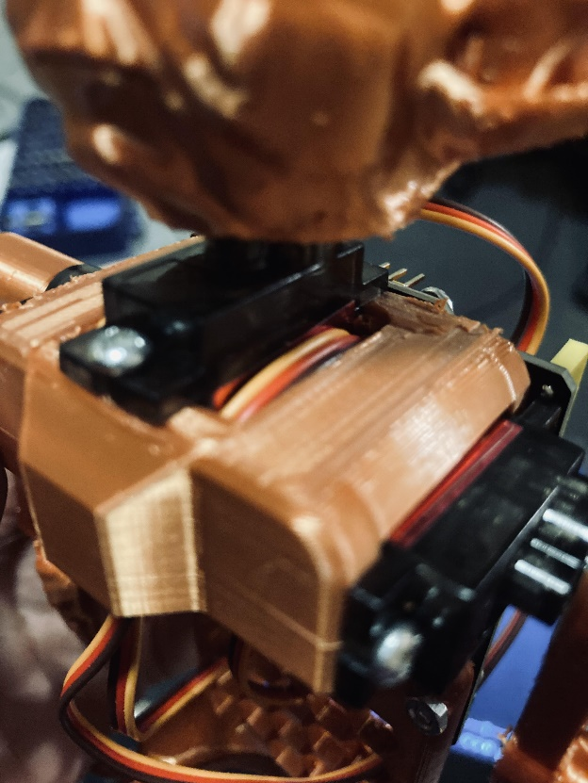

Note: wires for the arm servos should thread out, under the protrusion at the front of the torso.

Note: wire has some slack, as to not pose unwarranted stress.

Note: that during this section of installation, do not force the wires to be too tight, as this may pull the wires out of the torso section.

***Repeat servo mounting steps for other side arm servo.***

Step 3: attaching upper and lower torso.

Using the pin(s) locates on the upper torso section, use the upper screw holes on the Arduino to align the part.

In the other hole, use a m3*10mm bolt to secure the torso together, completing the main torso assembly.

Step 4: attaching head to torso.

Using a spare servo horn, place the fixture into the central main head servo, and gently rotate till clockwise until the servo hits its hard limit, roughly rotate the servo back 90 degrees anti-clockwise to find centre.

Remove the servo horn and use the hole located on the underside of the Yoda head to gently push the head onto the gear till it is firmly connected.

Note: should the head become loose during fitting or general operational wear, use a small section of electrical tape, or similar substitute to improve friction on the connection point, avoid using glues or adhesives as this may cause the servo may cease and become unusable.

Step 5: attaching hands to arms.

Use super glue on the flat side of the hands, and the lower, smaller sections of the arms, ensuring that the elbow pivot faces forwards, and that you have in fact glued the hands to make a left and a right arm.

If you don’t trust yourself, seek adult supervision or just use double sided tape so it can be somewhat easily removed should you have royally ballsed it up.

Step 6: attaching arms to torso.

Place a singular pronged servo horn into the upper section of the arm, using whatever utensils you have to hands e.g. tweezers, screwdriver, butter knife, maybe a teaspoon if you’re brave. Push the servo horn into the arm section, ensure that the side which actually goes onto the servo faces outwards of the arm, to ensure it can be affixed.

Rotate using an extra servo horn, towards the back of the torso till the hard limit is reached, then rotate back in the opposite direction by 90 degrees, to find a rough centre.

Using the servo horn screws, and either a magnetic Philips head screwdriver, or a regular screwdrivers with some blue tack, place the arm over the servo gear and screw through the hole on the shoulder portion of the arm.

***Repeat servo mounting steps for other side arm servo.***

Step 7: wiring.

Using the lower torso section, the hexagonal holes are perfect width to slide the servo connectors through, for sake of keeping track, use a central hole to slide the main head motor through, then a side hole, to slide either of the arm connectors through.

Brandon and mattie, this one is yours.

If Using Key studios board:

Due to modifications to the board, connections are really simple, in the middle of the board there are two sections of pins which are 3 wide, the rows are labelled as “s”, “5V”, and “G”, one section is labelled A0 – A5 and the other is labelled from 3 – 11.

Using the 3 – 11 side, connect the main head to pin 9, ensuring that the servo connectors orange wire goes to the s9 pin.

Connect the other two servos to s10 and s11.

Upload the “Yoda Sweep” program to the board, and the base exoskeleton of Yoda is complete.

If using unmodified Arduino uno board:

Wire each of the orange wires to pins 9, 10, and 11 ensuring that the head servo goes to pin 9.

Wire any of the grounds on the board to the three brown wires of the servo motors, this will probably require a degree of soldering or a small bread board to be mounted.

Wire any of the 5V lines to the red wires of the servos in the same way as discussed for the ground wires, this will also require soldering or a breadboard.

Upload the “Yoda Sweep” program to the board, and the base exoskeleton of Yoda is complete.

Step 8: “clothes and makeup”.

I don’t get paid enough to make sewing patterns, and as for painting Tamiya XF-76 is a pretty decent colour match for a Yoda skin tone.

As for material, a brown and a tan fabric tends to work best with the tan colouring being a material which can be easily frayed for easier weathering.

Hope you enjoy the Yoda.

P.S. use common sense during assembly.